**Mental Health Care Database**

Deliverable 3

Caitlyn Hunter

CIDM 3350

5/1/2024

Table of Contents

Overview …………………………………………………………………………………………………………………………………. 2

Business Rules …………………………………………………………………………………………………………………………. 4

EERD .………………………………………………………………………………………………………………………………………. 4

3rd Normal Form ………………………………………………………………………………………………………………………. 5

Table Create and Insert Records ………………………………………………………………………………………………. 6

Tables (SELECT and DESC) ……………………………………………………………………………………..………………. 18

SQL Queries .…………………………………………………………………………………………………………………………. 25

**Section 1 – Overview**

Focus: Mental Health Care

The proposed database focuses on the patient, doctor, nurse, lab, diagnosis, and medication entities.

Data Management Problems

This database aims to solve three data management problems faced in the mental health care industry. These problems relate respectively to levels of care, diagnoses, and medication.

When it comes to mental health, patients require different levels of care. This changes not only from patient to patient but throughout an individual’s lifetime as well. For example, a patient who starts in an emergency inpatient hospital may transition to routine therapy, or a patient who is attending therapy may face a crisis and need hospitalization. This can quickly become confusing when looking at records; by having a database, doctors can efficiently see which patients require which level of care.

Next, patients often are diagnosed with multiple conditions during multiple levels of care. When there is a lack of communication between those levels of care, a doctor may not have the full picture when treating a patient. Not only is this ineffective, but it is harmful to the patient and time-consuming for all parties involved. A database would easily solve this problem by fixing this lack of communication.

Finally, patients usually need more than one medication. Providers must be aware of all the medications a patient is prescribed before suggesting a new one to add as there could be adverse reactions between the medications. In addition, these medications can change throughout treatment and diagnoses until providers find the most effective prescription. All this leads to the challenge of tracking both current and past medications. With a database, this problem, though still challenging, is simplified.

Motivation

The motivation behind this database is to better patient care regarding mental health services. Those seeking mental health care are not in a place to receive subpar treatment, yet sadly it is often a struggle to find adequate care in the United States. Treatment can be a long journey, and it is even more complicated when providers are relying on the patient to remember all the needed information.

Even when appropriate treatment is found, patients can feel like something to check off a to-do list. By implementing a functional database, mental health service providers can spend less time keeping track of information. This in turn allows them to spend more time connecting with patients and caring for their mental health needs. Though it may seem like a simplistic solution, using a database gets patients one step closer to better mental health care.

Potential Benefits

The benefits of using a database in mental health care are better organization, multi-departmental communication, security, and--ultimately--better care for those with mental health conditions.

With a database, providers can maintain better, easier organization. Not only would a database keep track of patients, but also the needed level of care, medications, and diagnosed conditions. In addition, doctors between departments (in-patient, intensive outpatient, therapy, etc.) would all have appropriate access to each patient’s information. This allows for seamless transitions between levels of care because all departments would have the needed knowledge about each patient. Finally, a database could be secured, which would protect the personal information of each patient and maintain confidentiality.

Each of these areas—organization, communication, and security—all lead to better care for patients. Patients will no longer have to be concerned about doctors not knowing their medications or diagnoses. In addition, they will have easier transitions between levels of care. Finally, patients can trust that confidentiality will be maintained. All this builds trust in the care received, which is crucial to mental health services.

Potential Users

Potential users include front desk staff, pharmacists, and doctors.

First, when checking in for treatment, whether it is inpatient, intensive outpatient (from here on referenced as IOP), or therapy, front desk staff can use the database to keep track of patient names and check-in information. This would make their job easier in the future, as the data can be stored in the database and retrieved for future appointments.

Pharmacists can also benefit from the database. By sending medication information connected to each patient, pharmacy staff can efficiently fill prescriptions. In addition, the database can be kept updated, so that staff do not have to be concerned about data redundancy or—on the other hand—not having prescription information on patients.

Finally, doctors, such as psychiatrists or therapists would likely be the most common users of the database. From the first patient visit to the end of their care journey, doctors need to know all appropriate information on the patient. They must keep track of diagnoses, prescribed medications, and level of care in order to treat the patient effectively. By having access to the database, doctors can use the data to recommend the next treatment step.

**Section 2 – Business Rules**

Below are the business rules relating to the proposed database.

1. When Patients arrive for any level of care, they are required to provide their SSN (identifier), First and Last Name, Date of Birth, and Phone Number(s). A patient can only be one of the following categories: inpatient, intensive outpatient, or outpatient.
   1. If a patient is inpatient, they must have a room number.
   2. If a patient is intensive outpatient, they must have a schedule.
   3. If a patient is outpatient, they must have a therapist.
2. A patient must be seen by at least one doctor, who has a Doctor ID (identifier) and First and Last name. Doctors must be assigned at least one patient.
3. The doctor, patient, and lab work together to find at least one correct diagnosis for the patient. The lab has a Lab ID (identifier), Location, and Phone number(s). A diagnosis has a Diagnosis ID (identifier) Date of diagnosis, and Symptom(s).
4. A patient also has at least one nurse who administers medication. Just like doctors, nurses must be assigned at least one patient. A nurse has a nurse ID (identifier), name (first and last), and any relevant certificates. Medication has a Prescription ID (identifier), name of the medication, and dose.

**Section 3 – EERD**

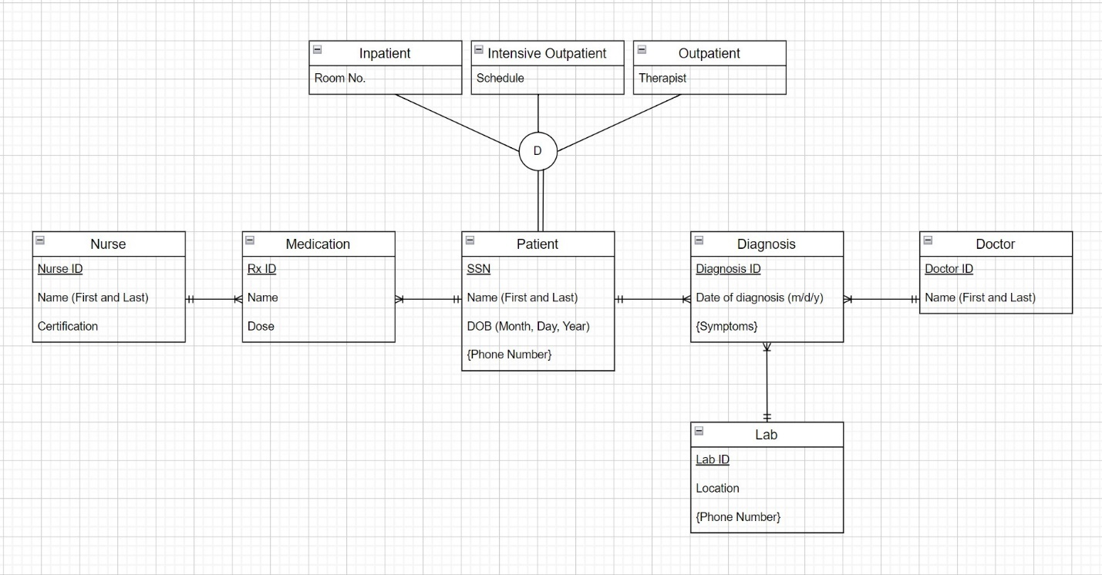

**Section 4 – 3rd Normal Form**

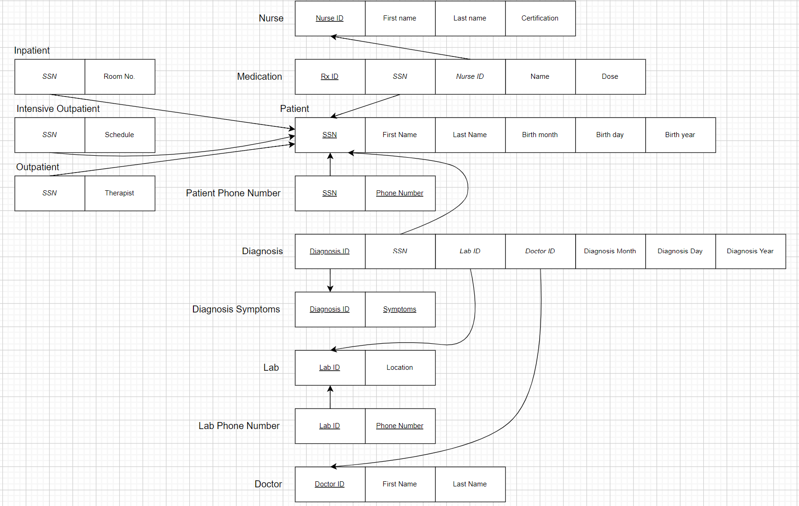

**Section 5 – Table Creation and Insert Records**

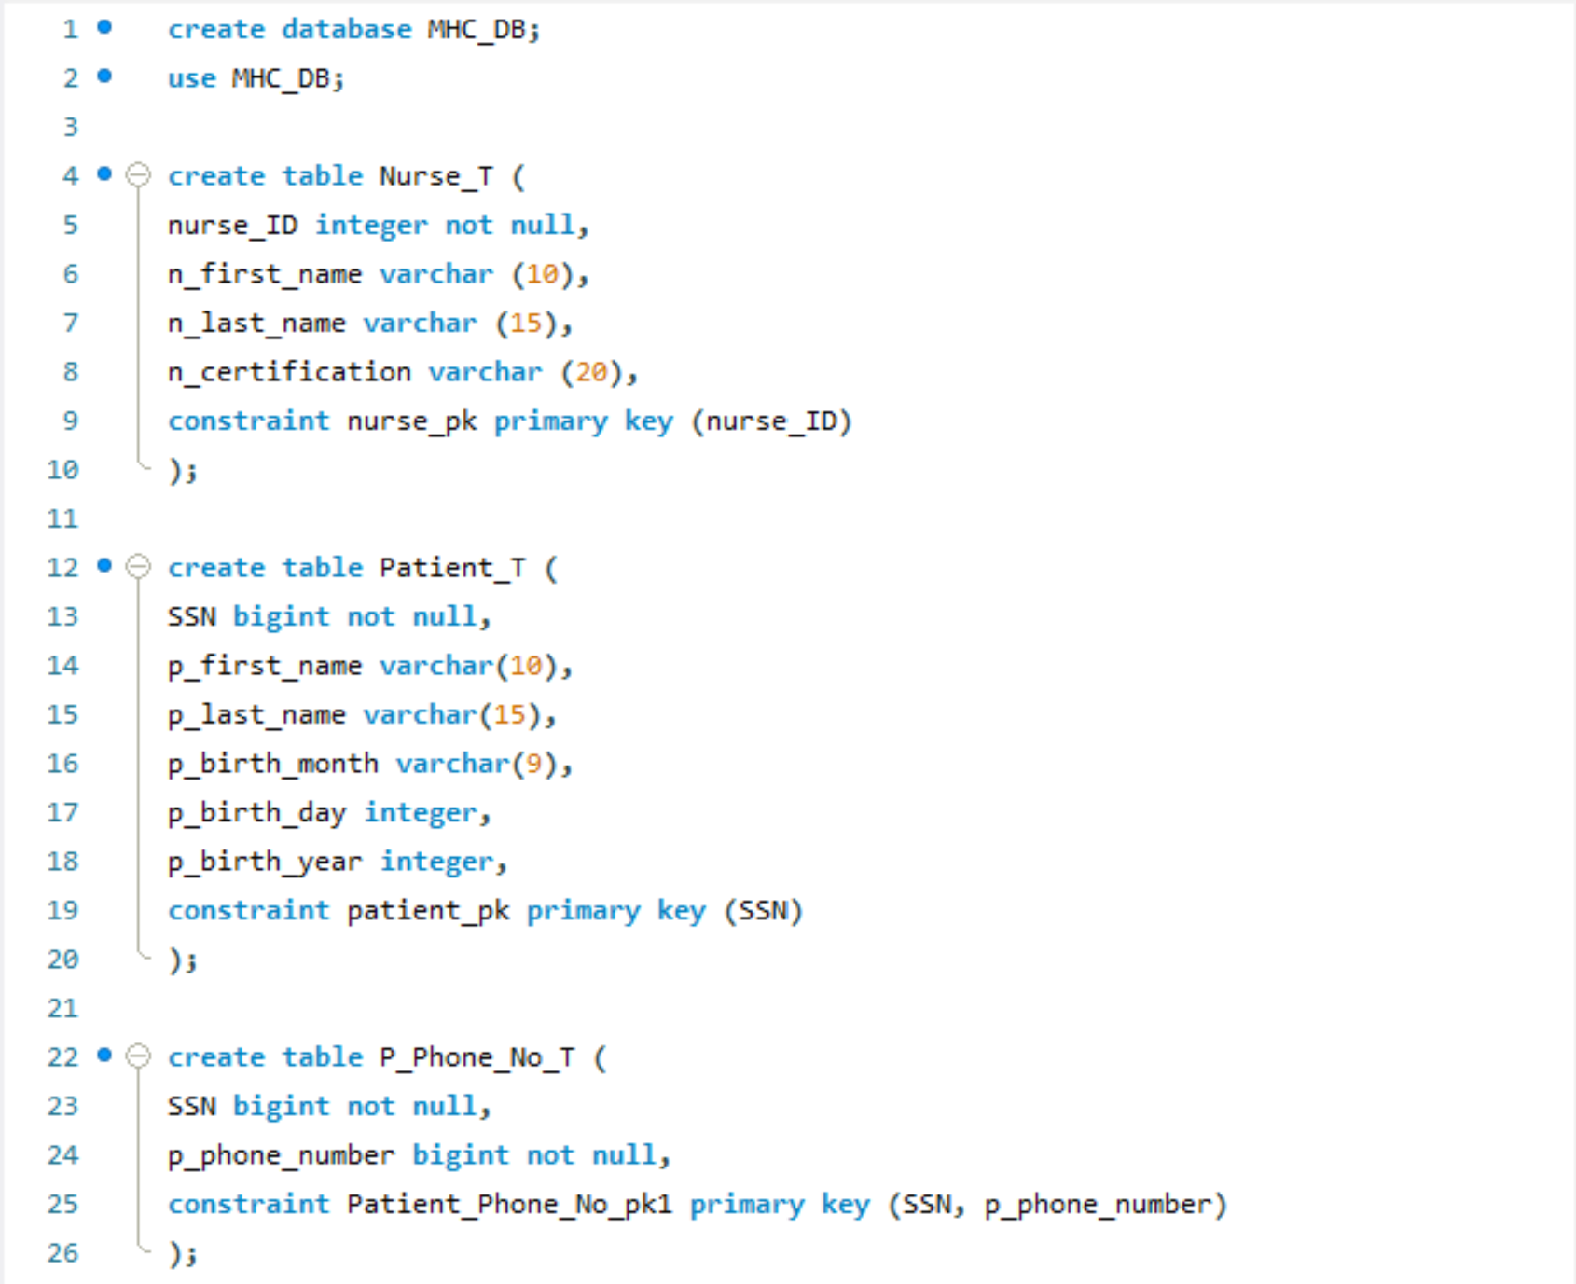

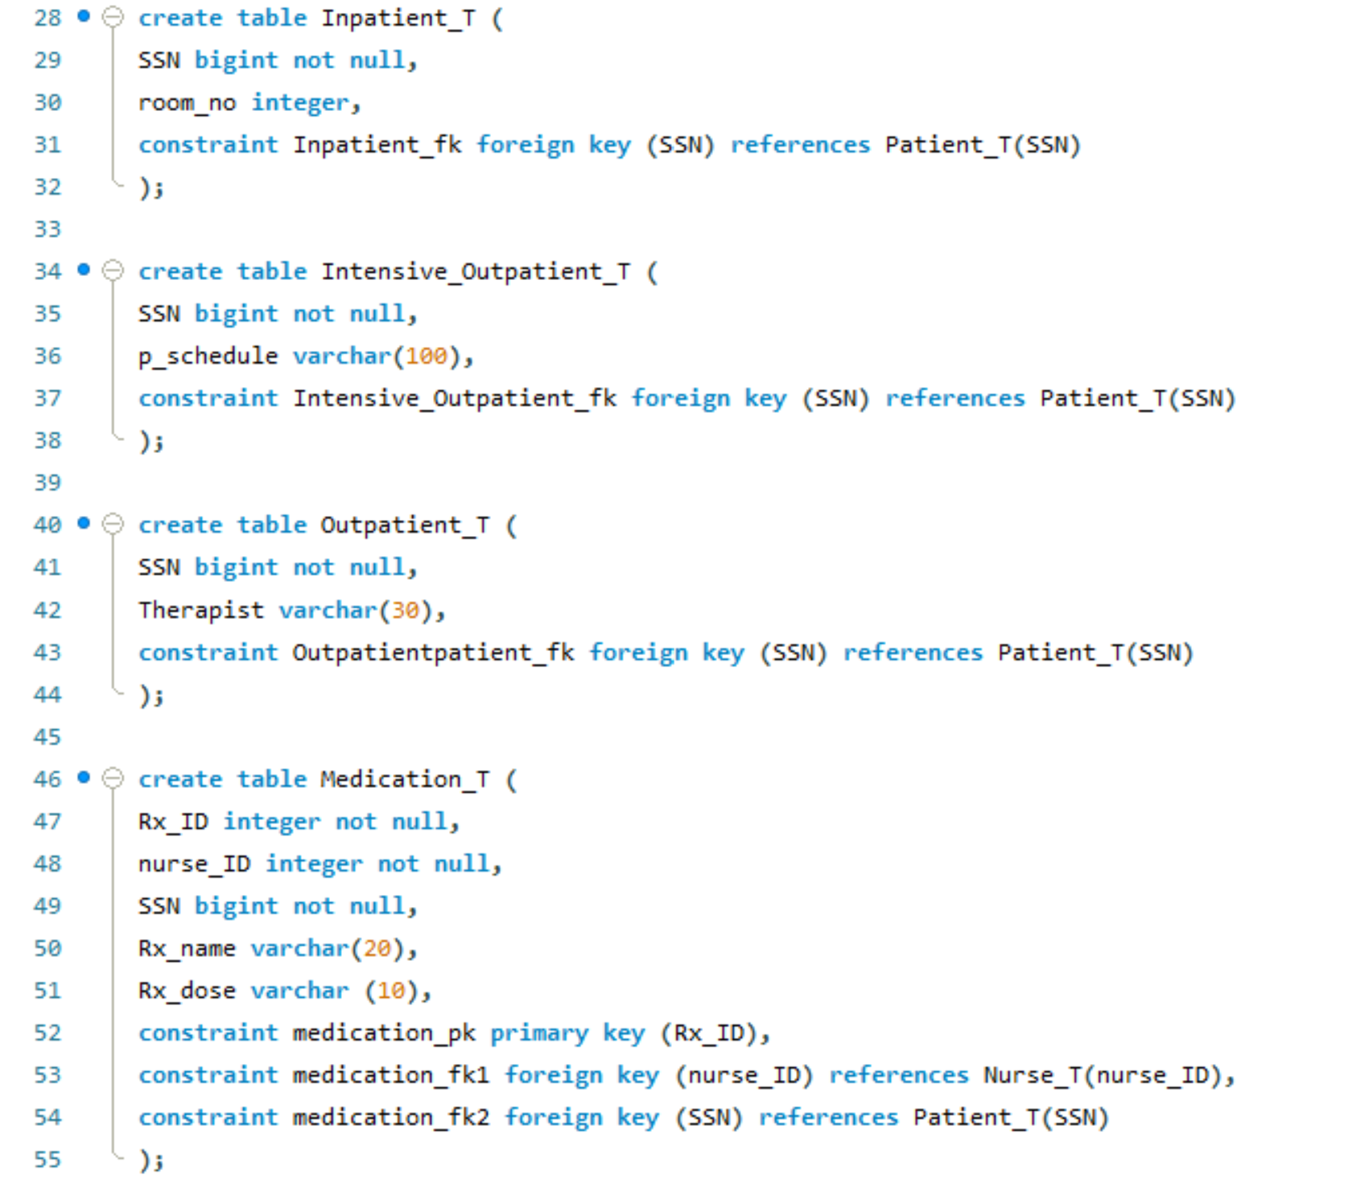 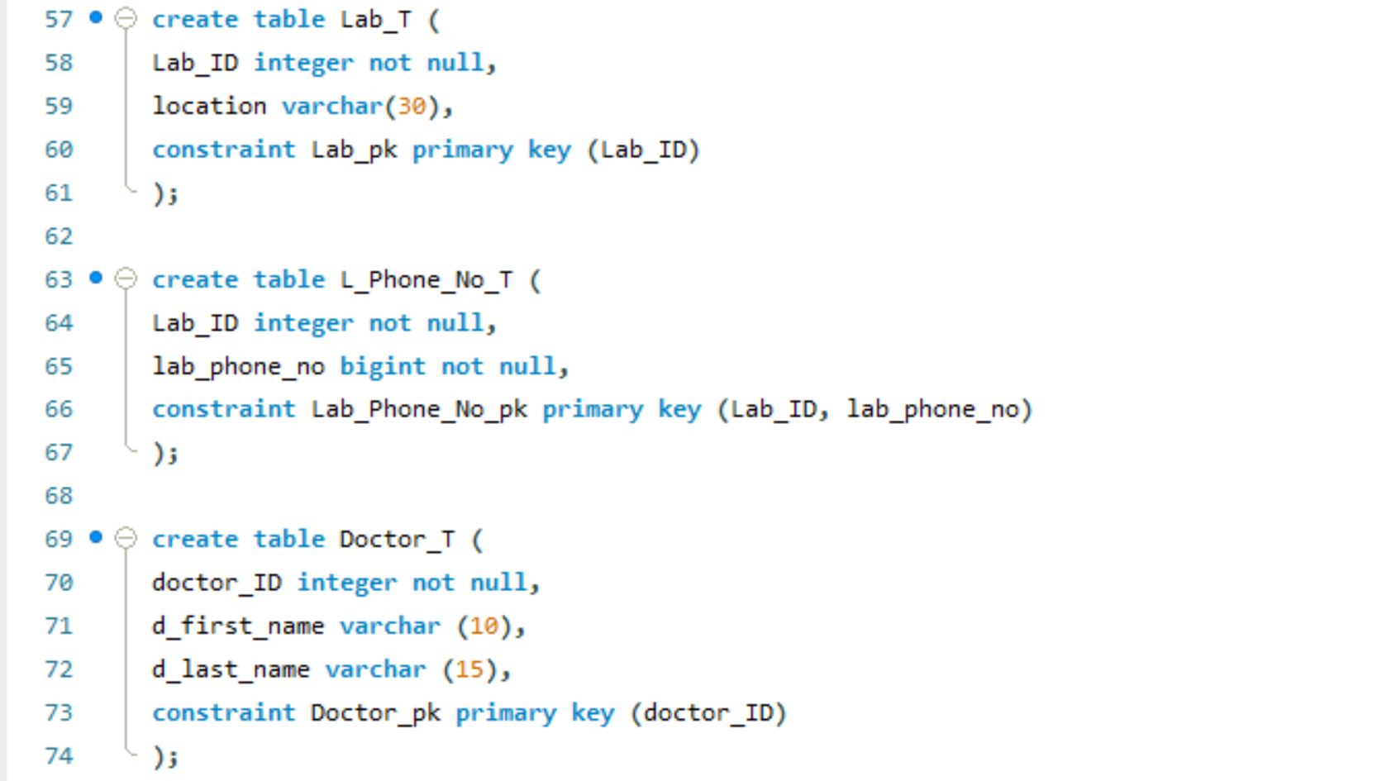 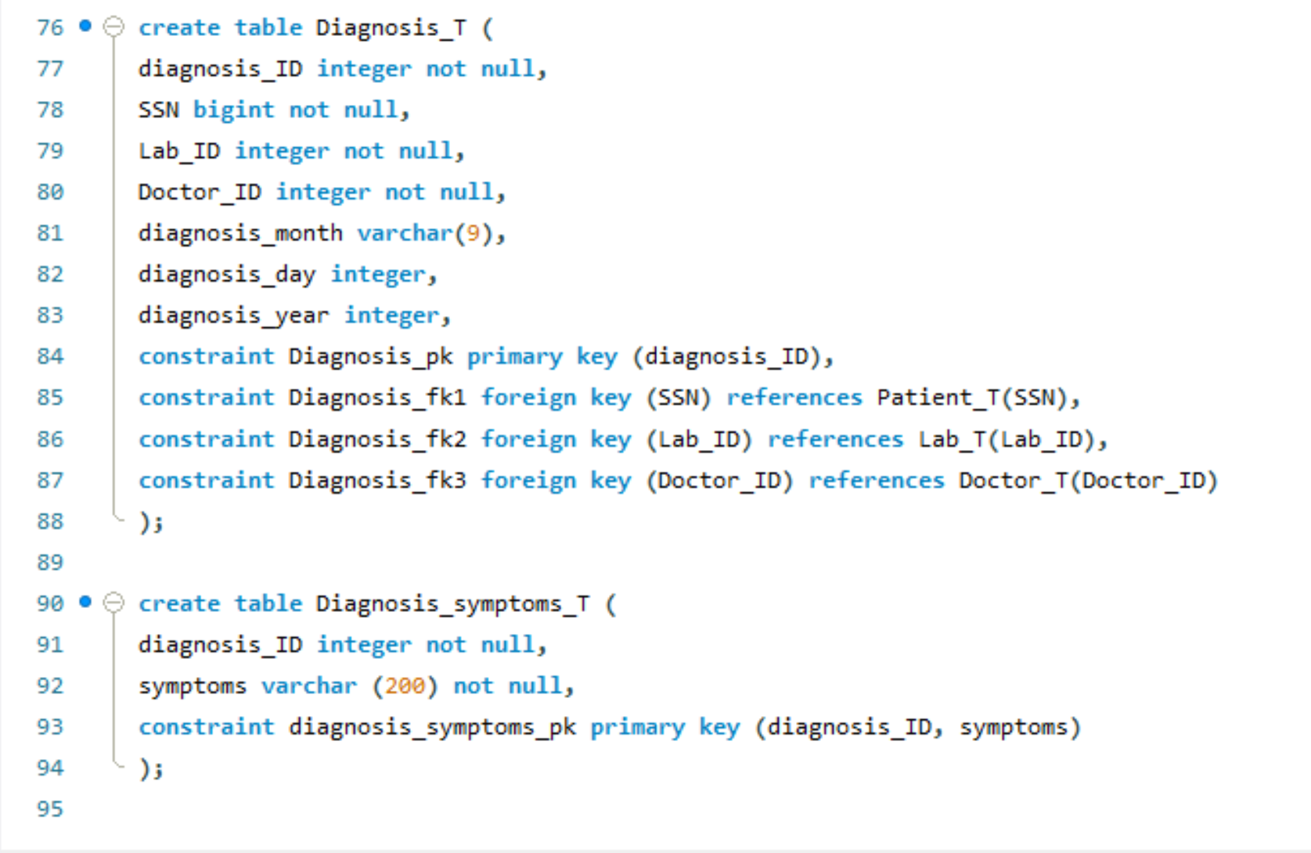

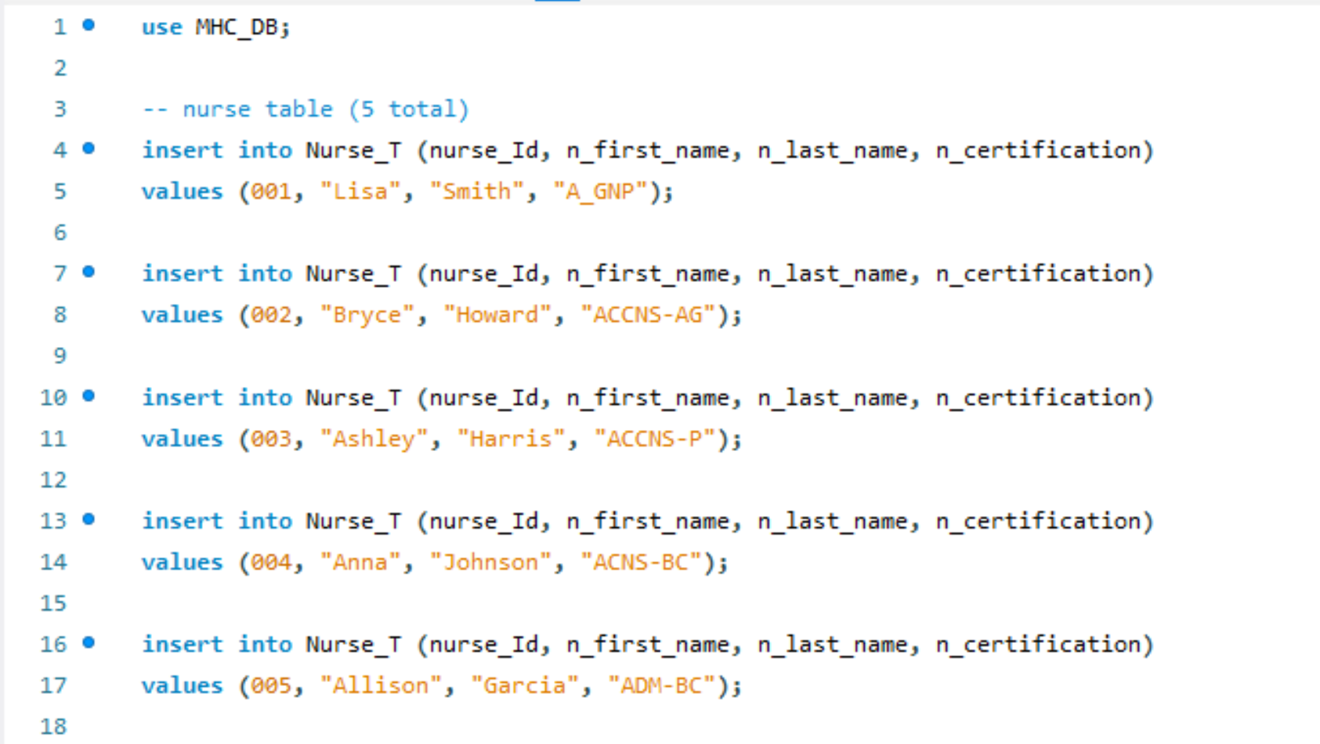

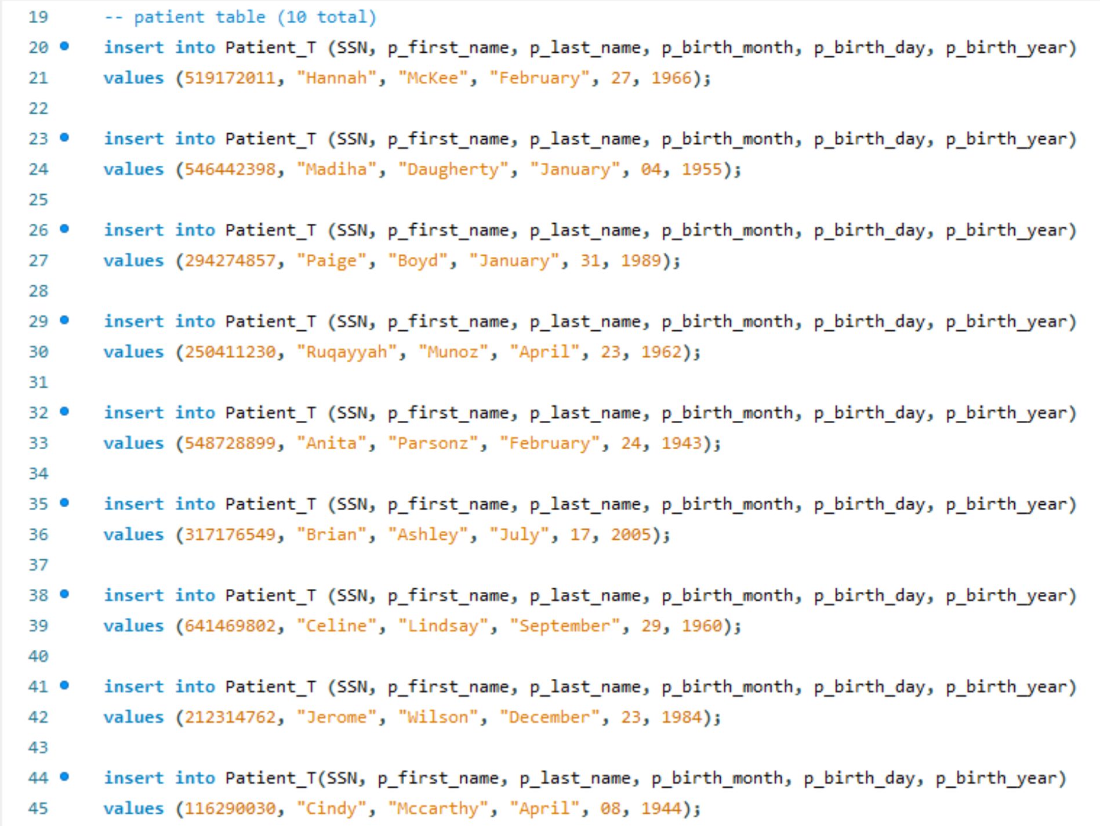

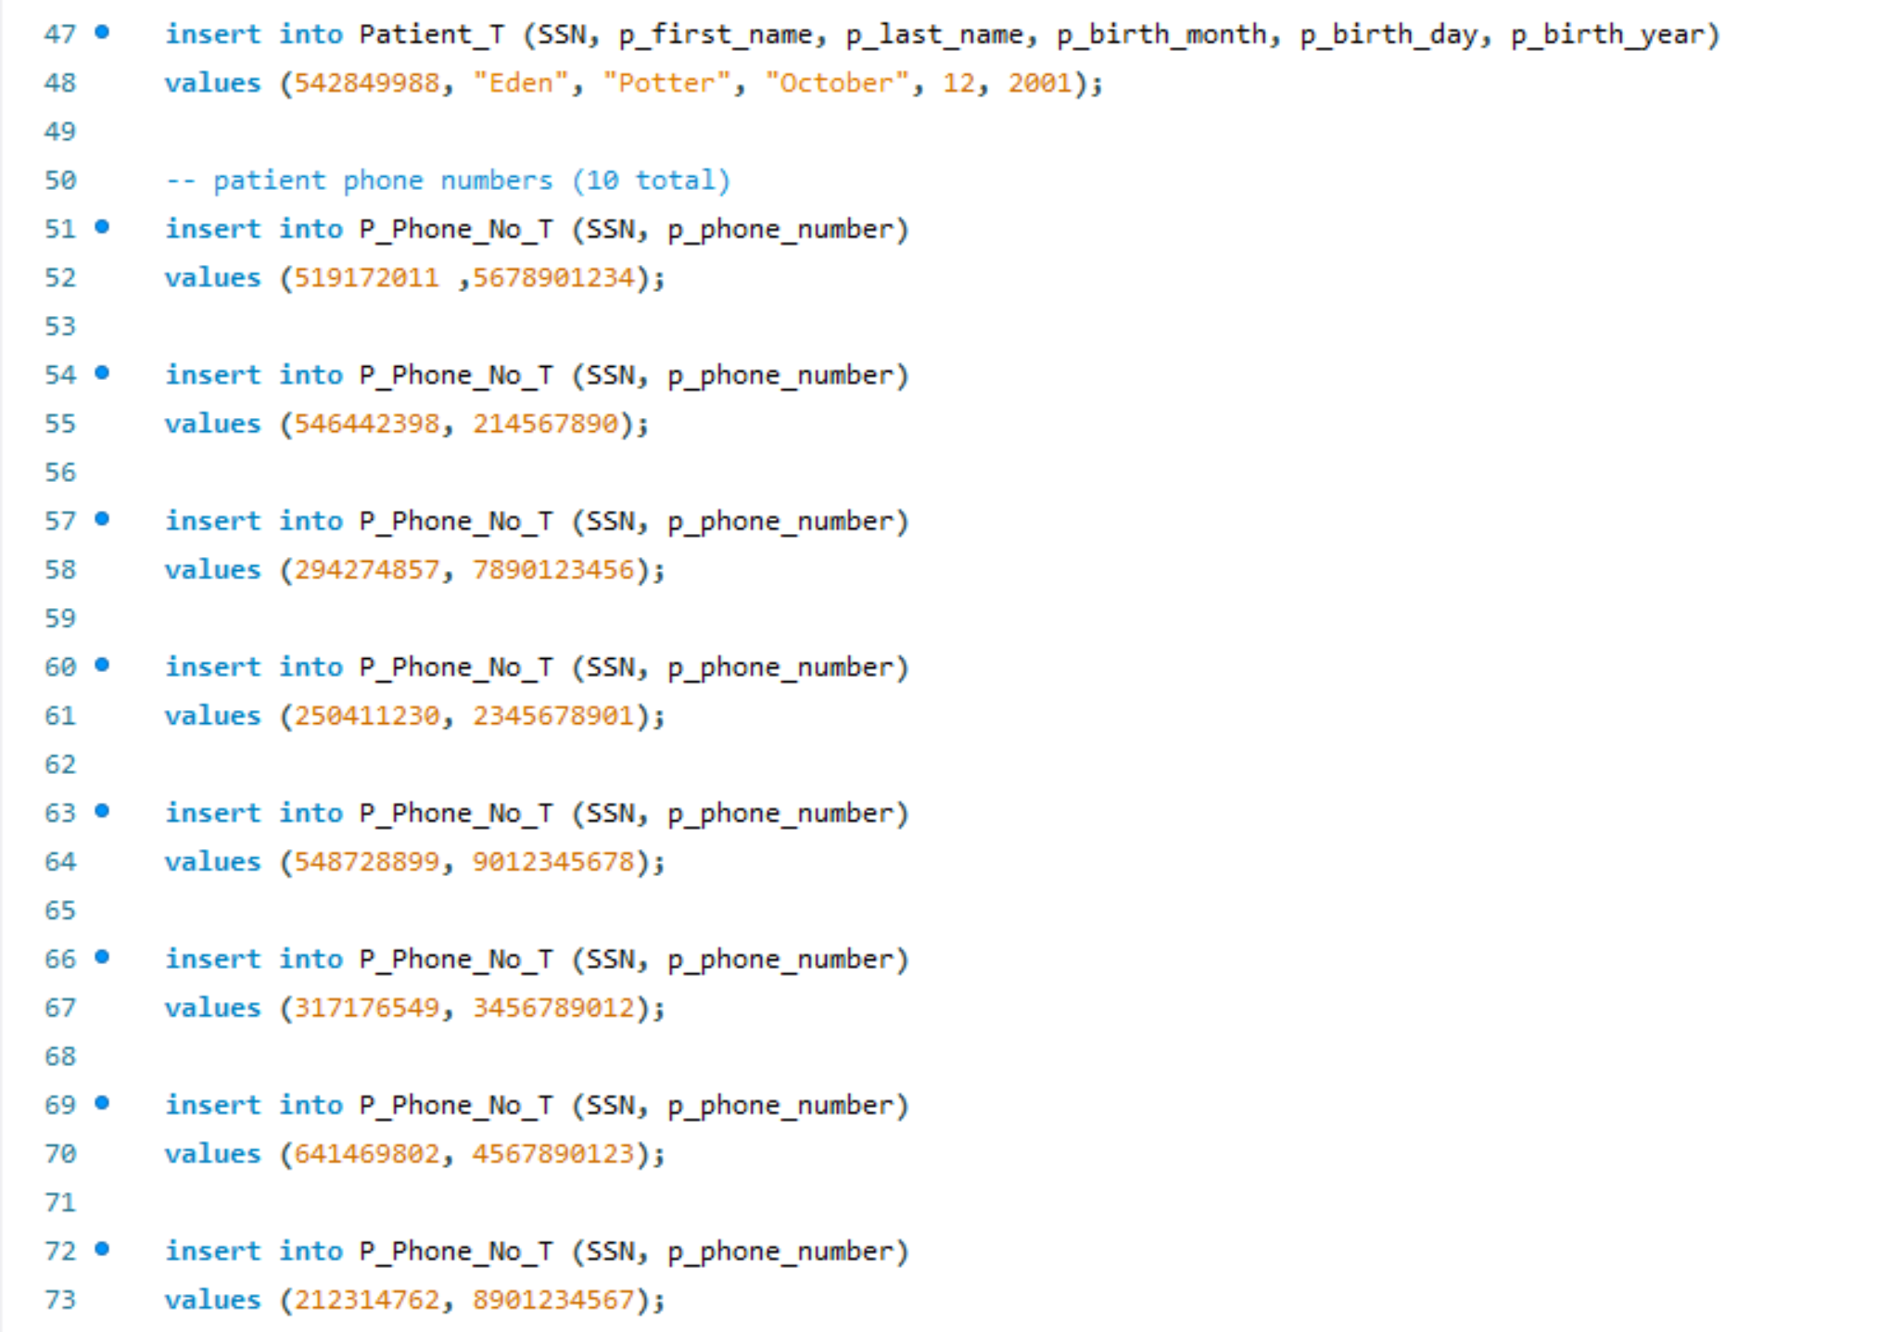

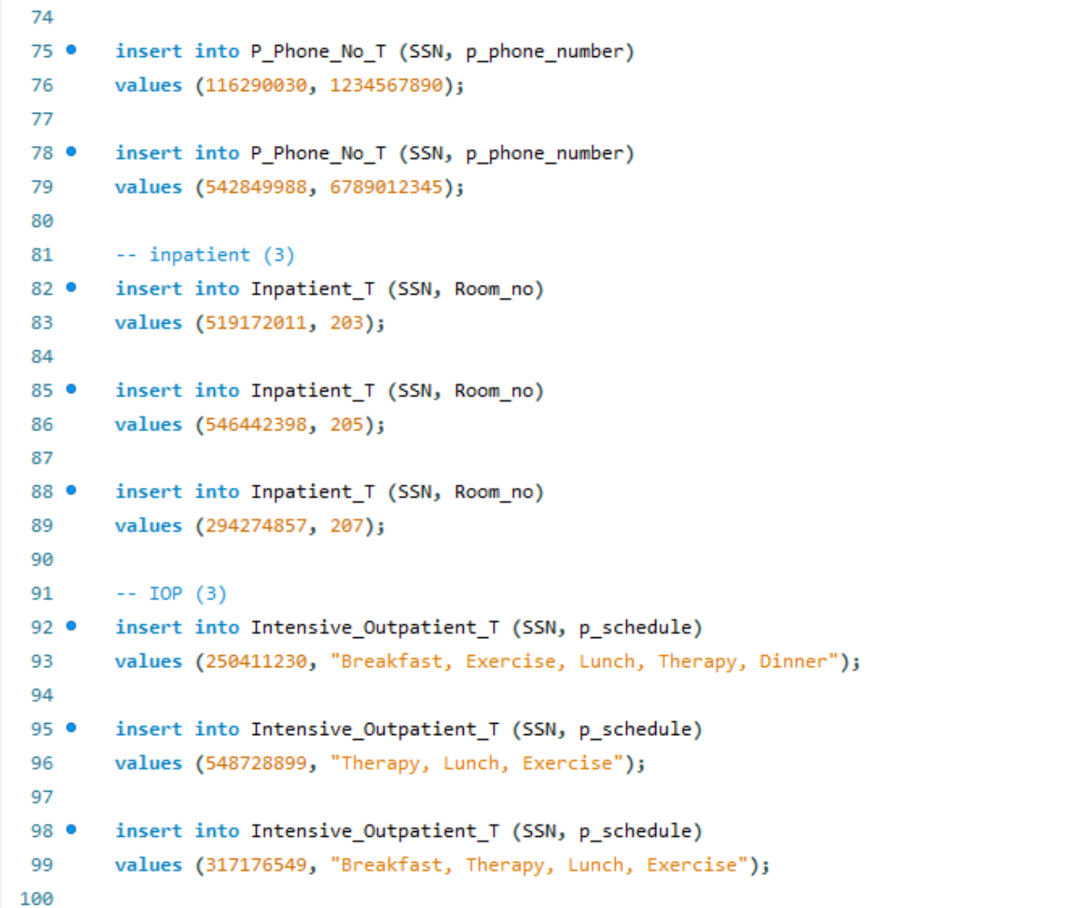

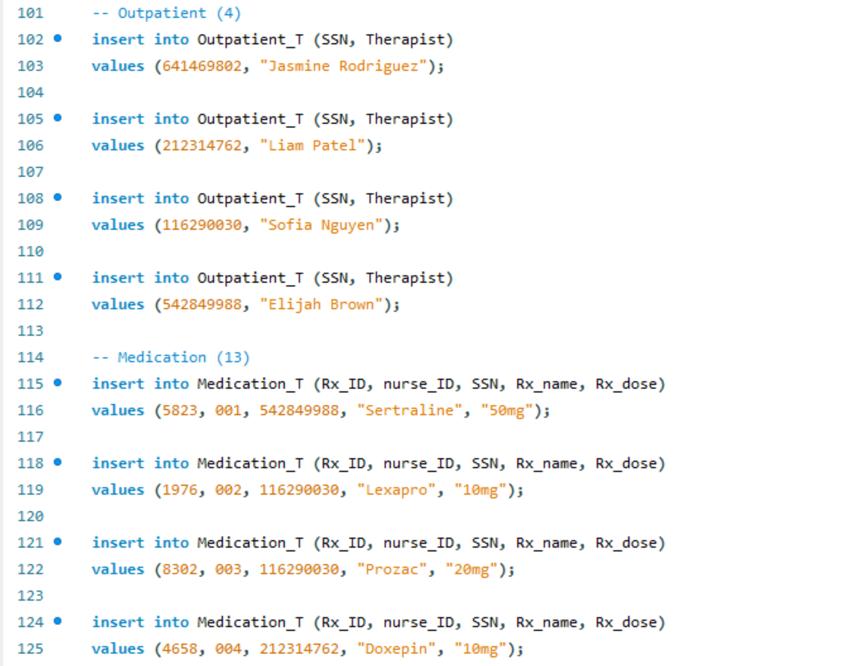

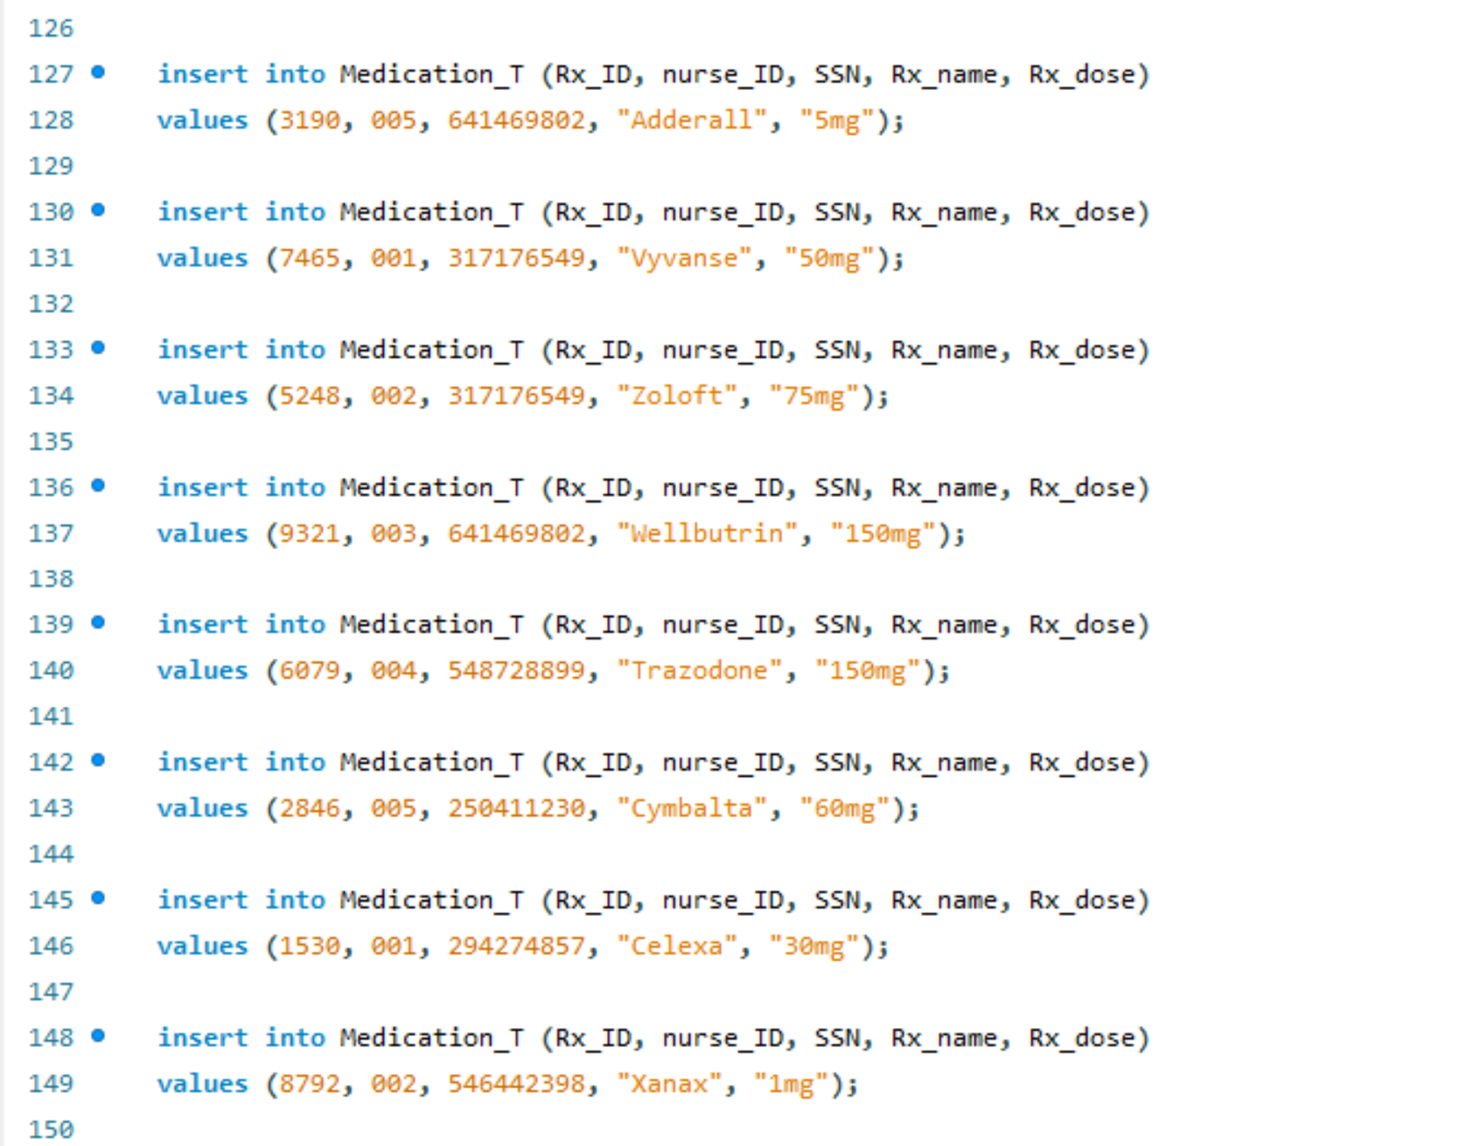 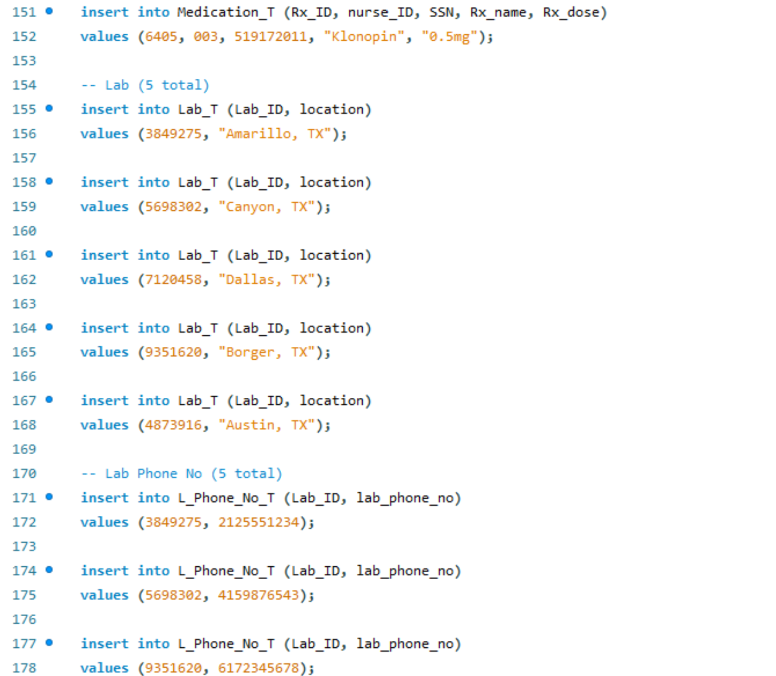

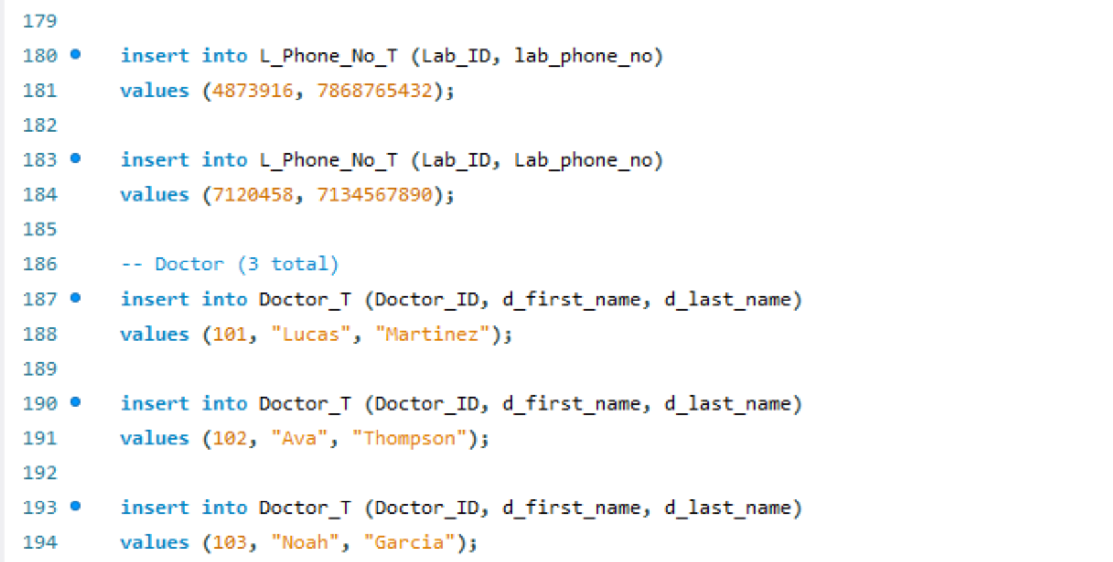

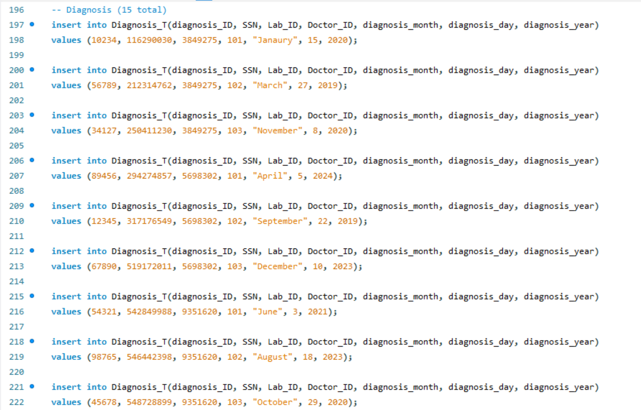 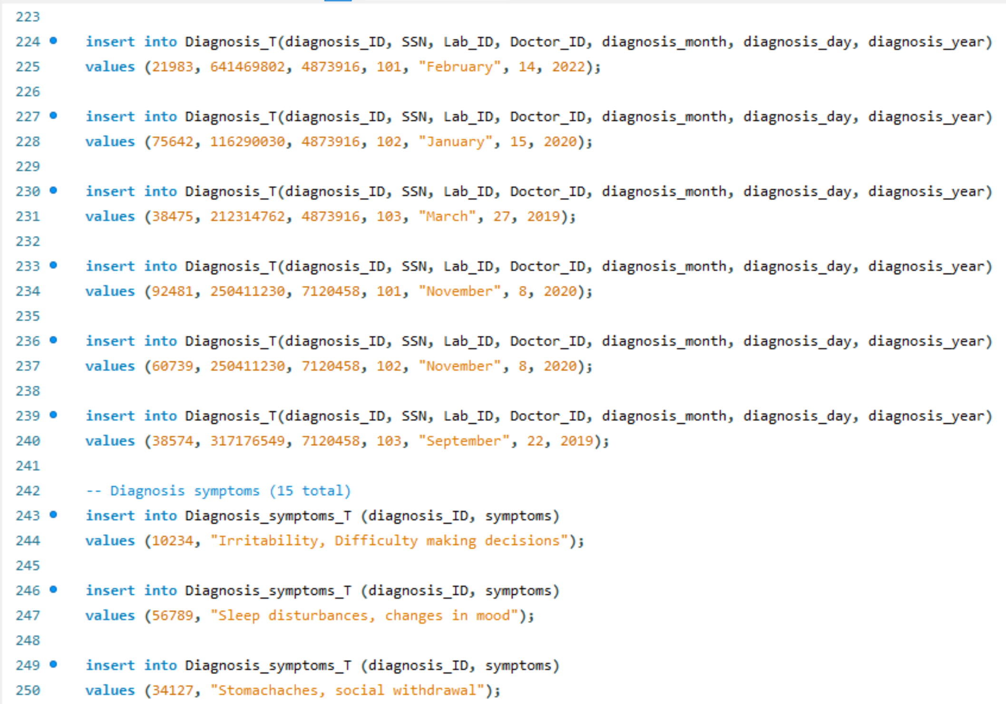 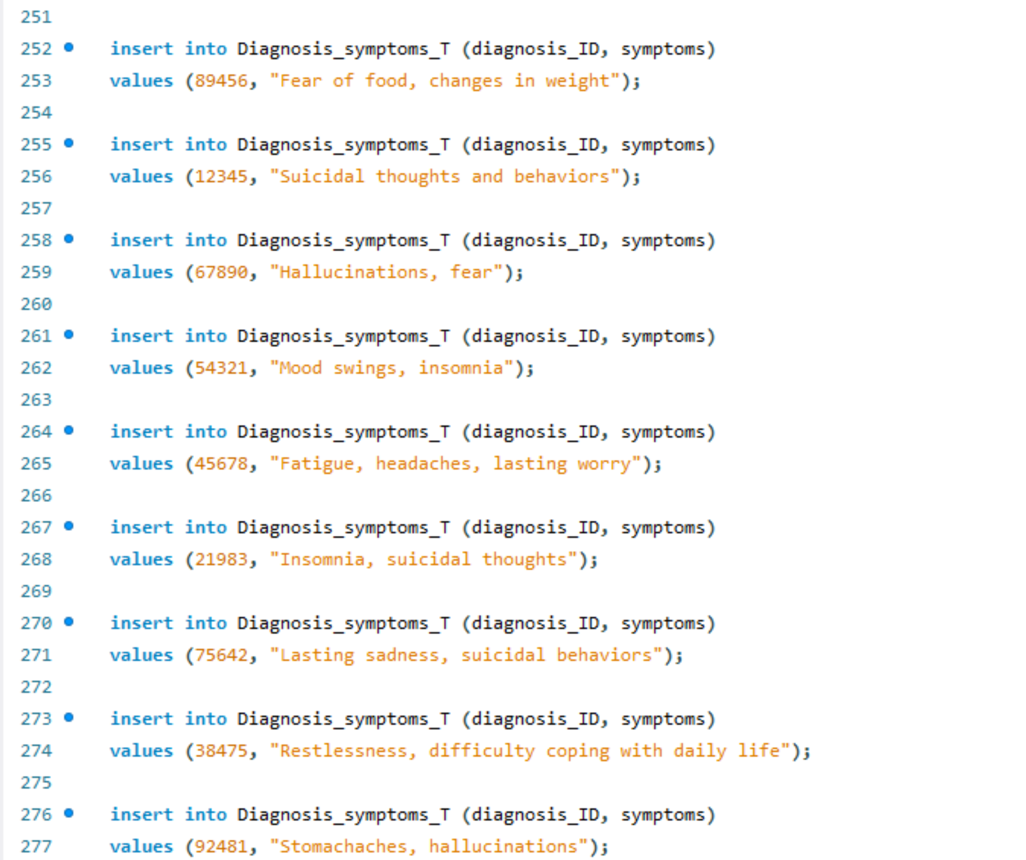 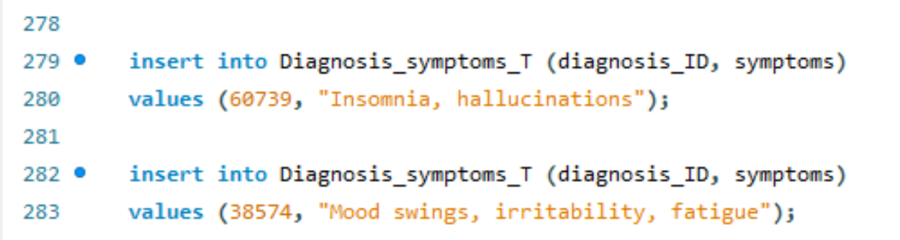

**Section 6 – Tables (SELECT and DESC)**

*Nurse Table*

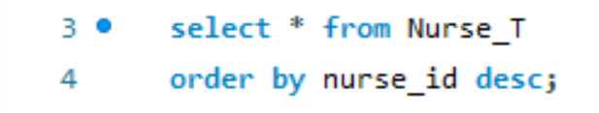

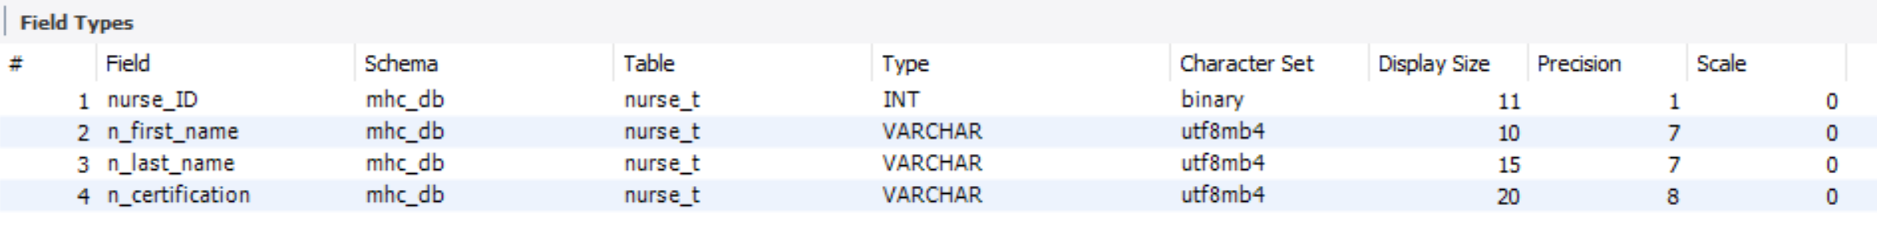

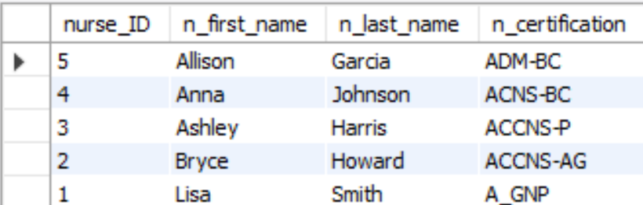

*Patient Table*

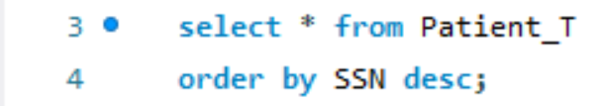

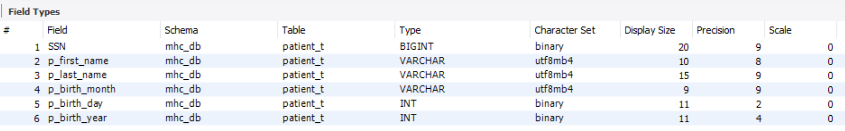

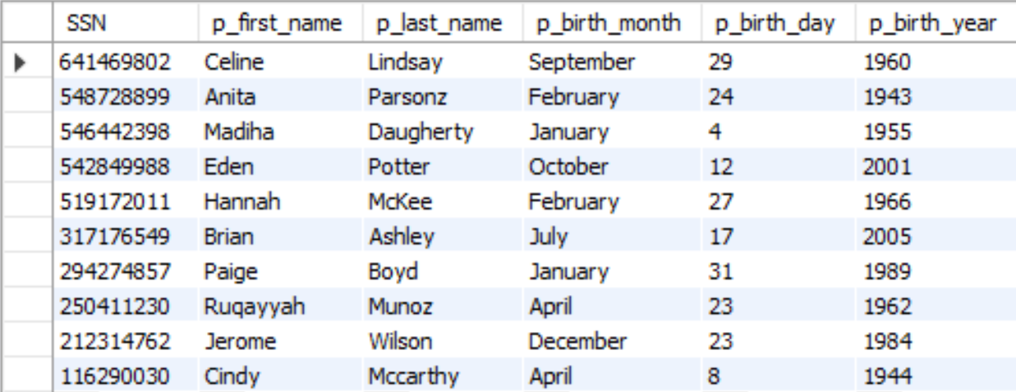

*Patient Phone Number Table*

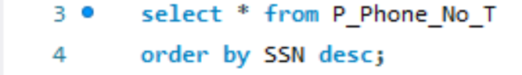



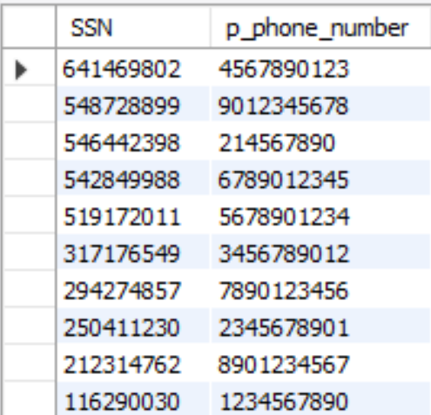

*Inpatient Table*

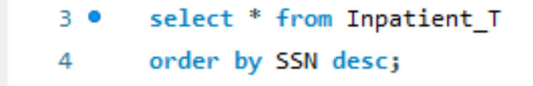

**

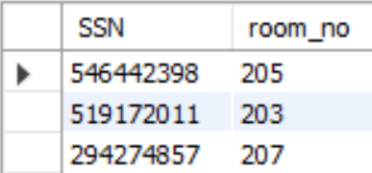

*Intensive Outpatient Table*

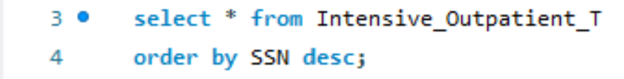

**

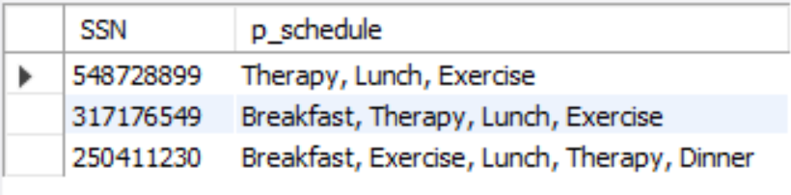

*Outpatient Table*

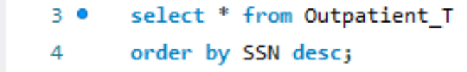

**

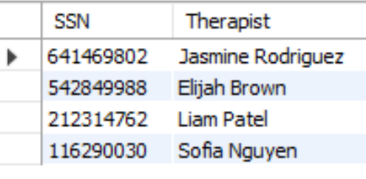

*Medication Table*

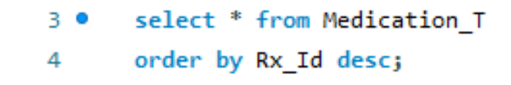

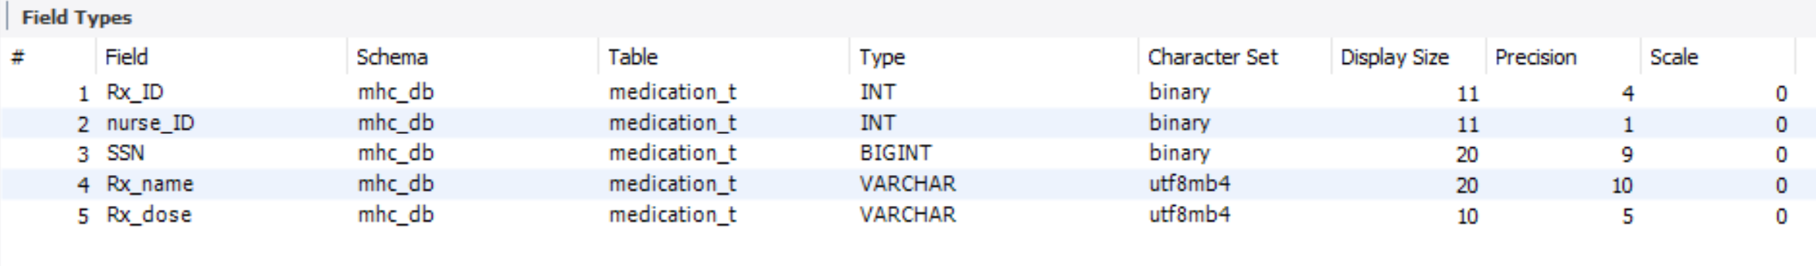

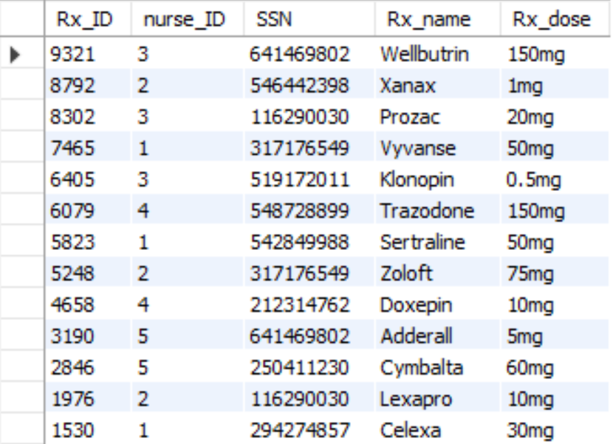

*Lab Table*

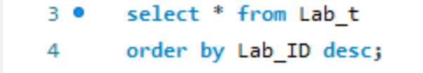

**

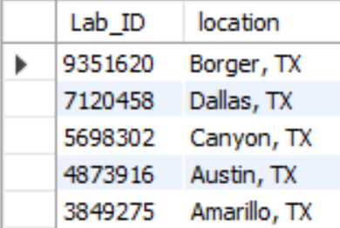

*Lab Phone Number Table*

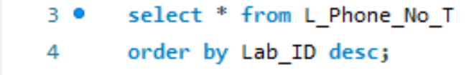

**

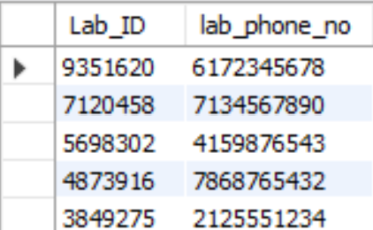

*Doctor Table*

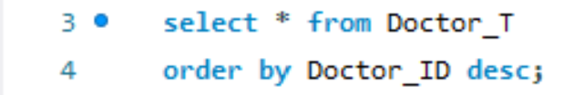

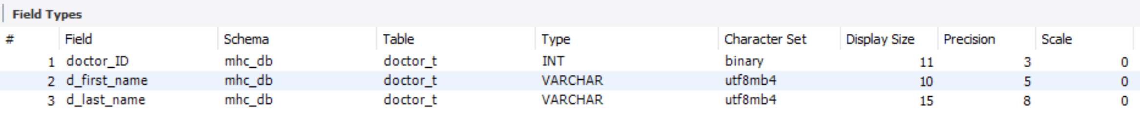

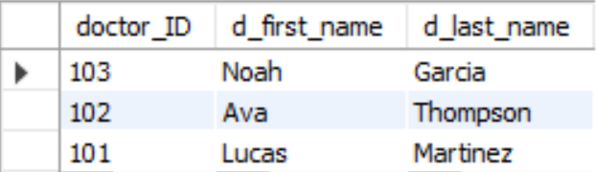

*Diagnosis Table*

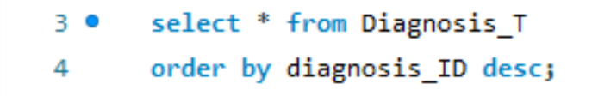

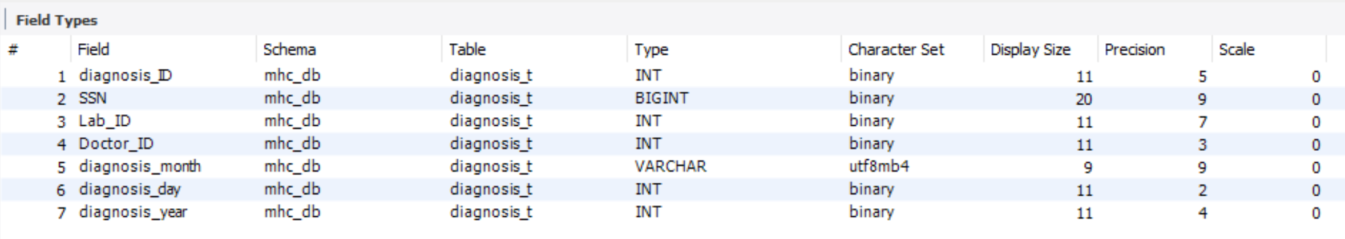

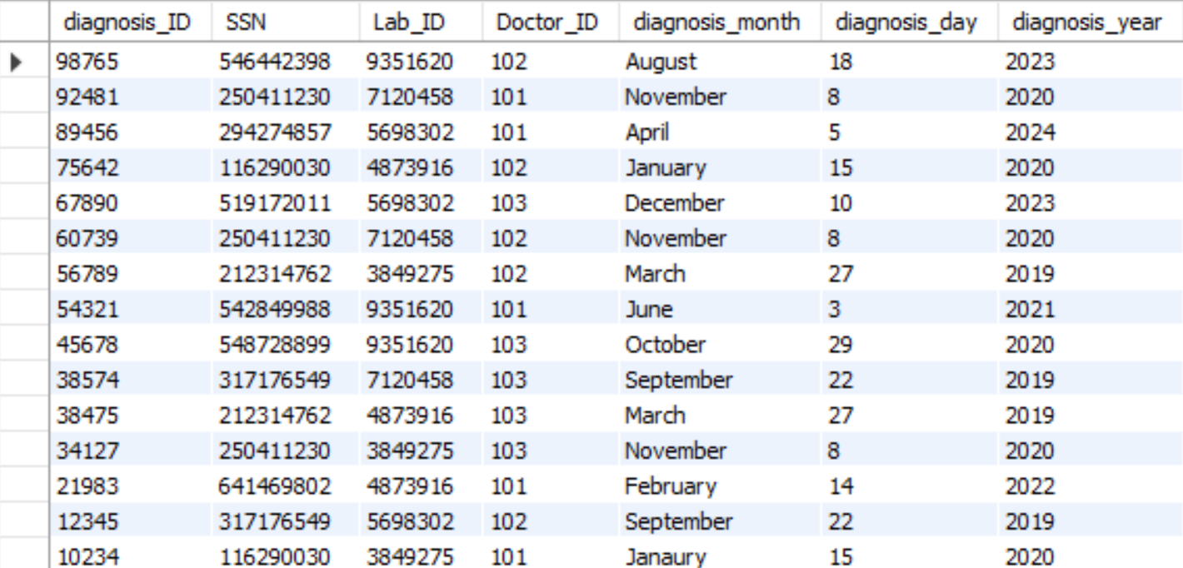

*Diagnosis Symptoms Table*

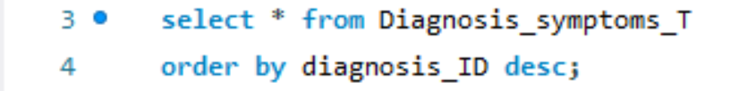

**

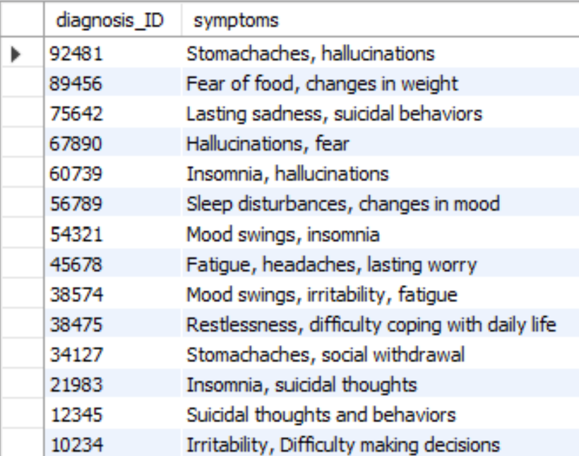

**Section 7 – SQL Queries**

*Query 1*

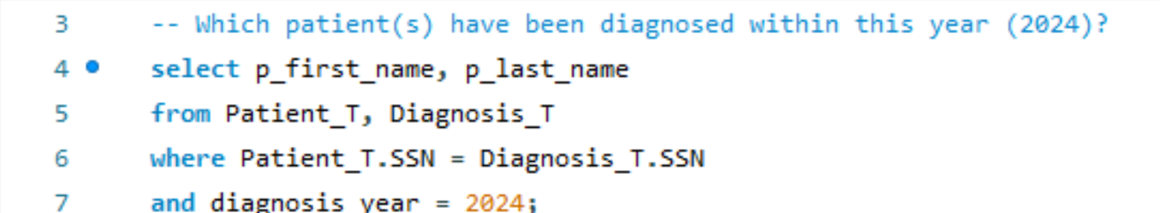

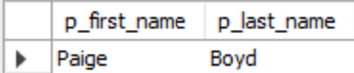

*Query 2*

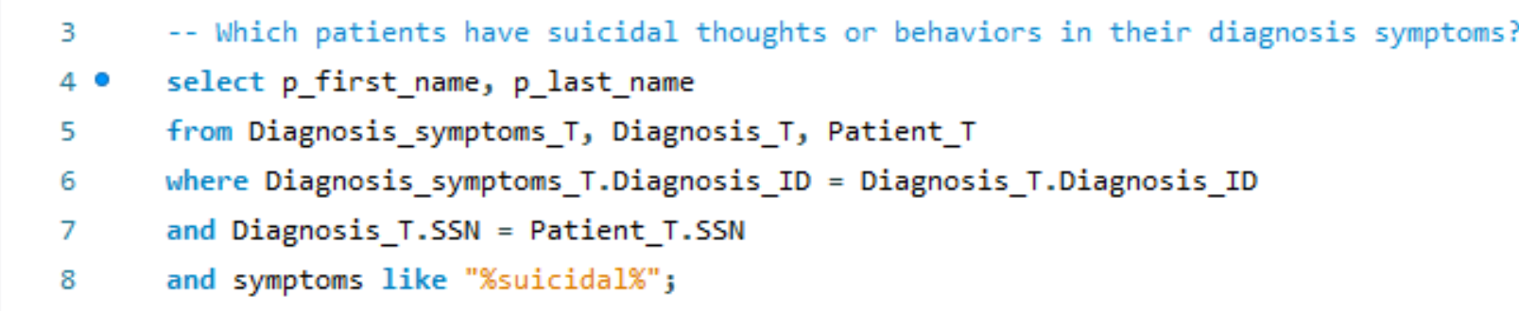

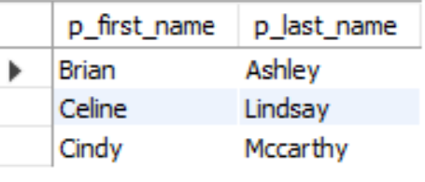

*Query 3*

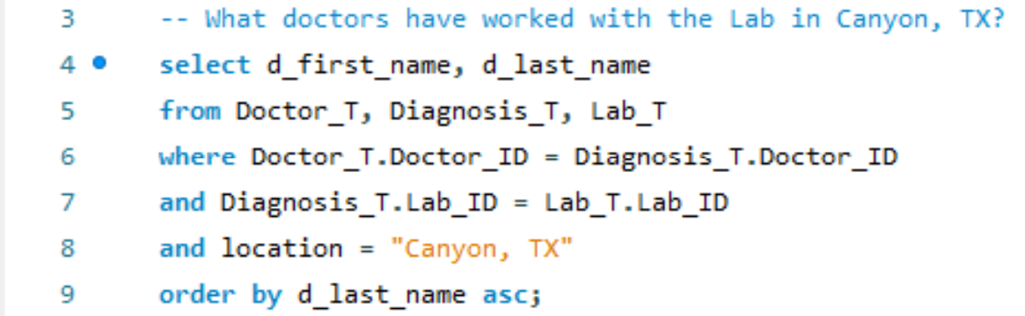

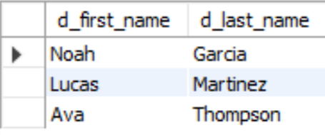

*Query 4*

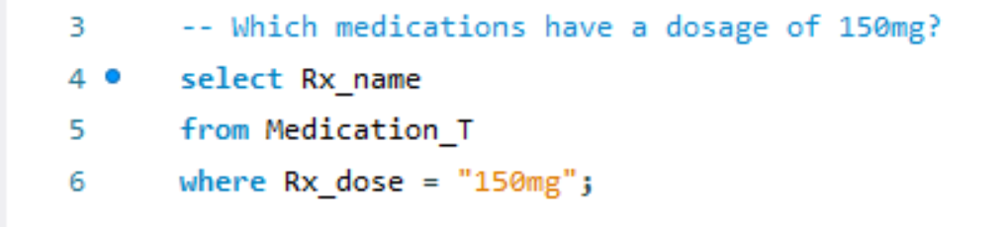

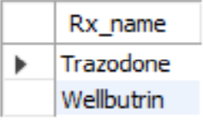

*Query 5*

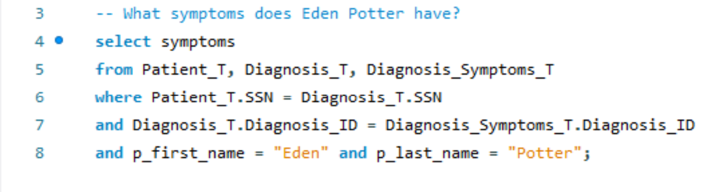

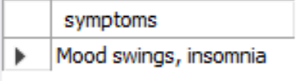

*Query 6*

